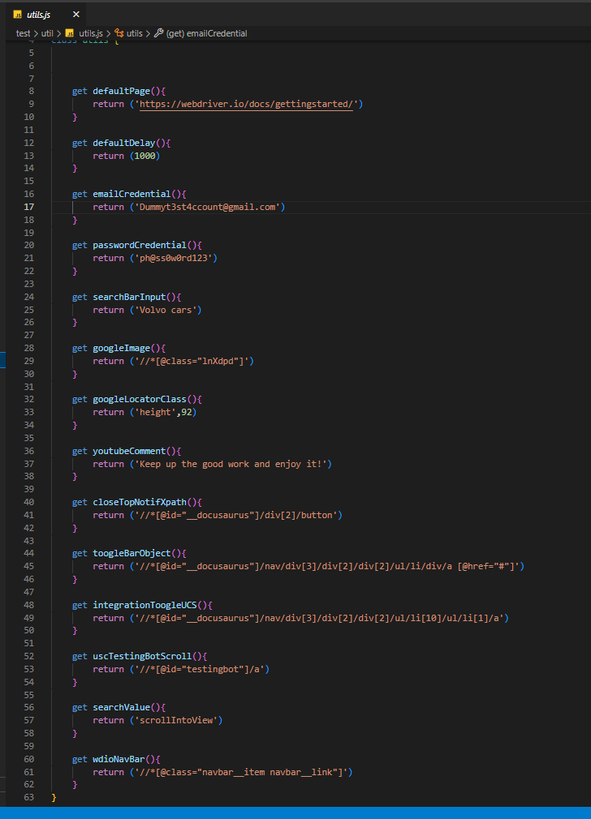Utils is a reusable value, you can use it in any components you needed.

PageObjectModel

This is where we indicate the xpath or the element.

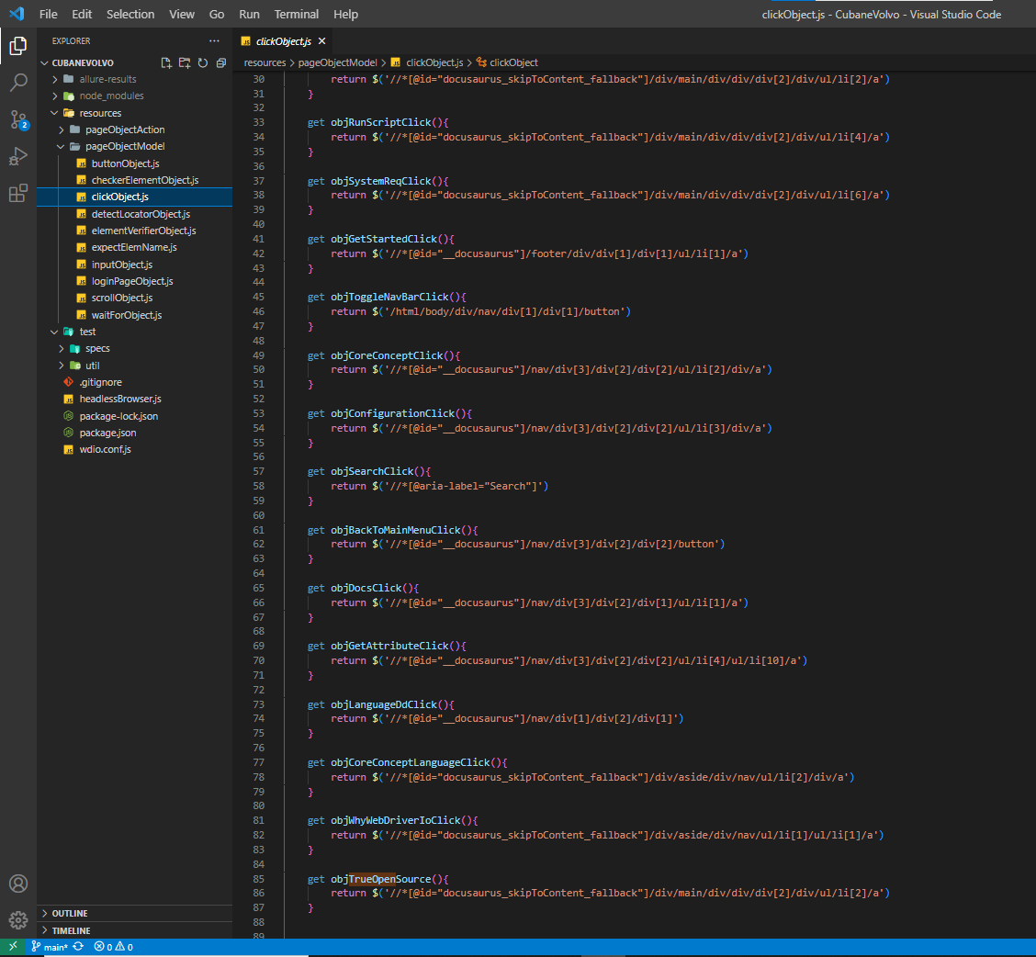

PageObjectAction

This is where we put the webdriverio methond it depends on what we need. So in the picture I used the example of click.

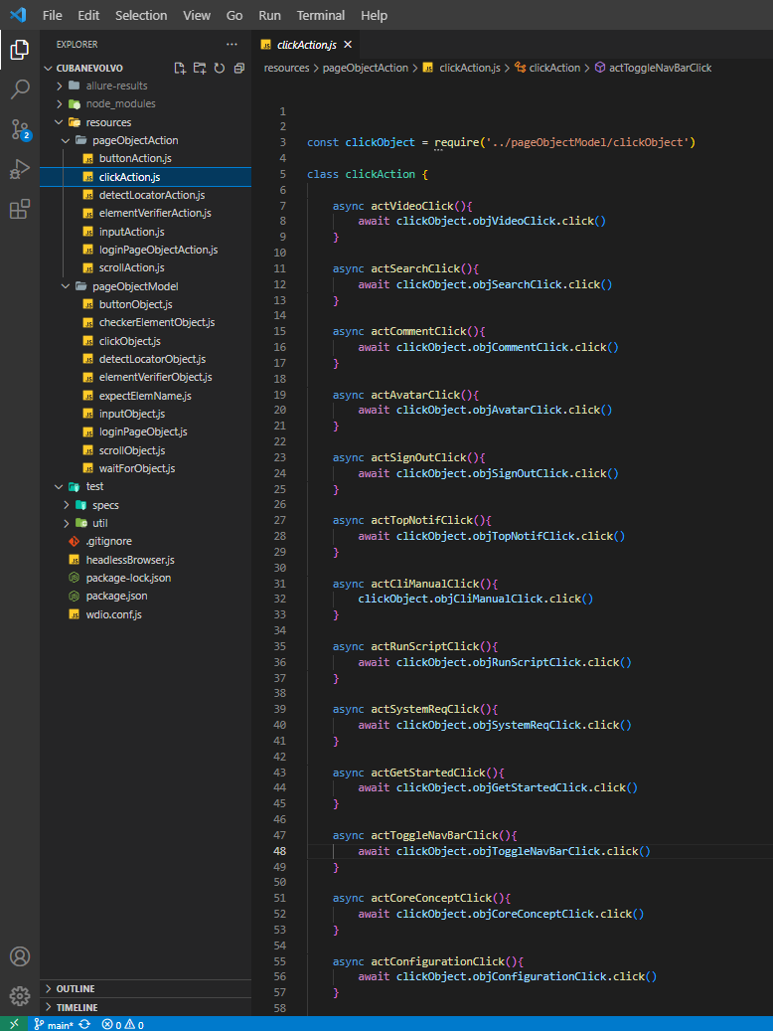

Inside of the specs folder is the main file which is the volvoTest.

Inside the VolvoTest is we have a 4 It

It, It’s where we do the component testing.

So I have 4 It because I did divide the given task into small ones so we can check and be much more readable to other developers.

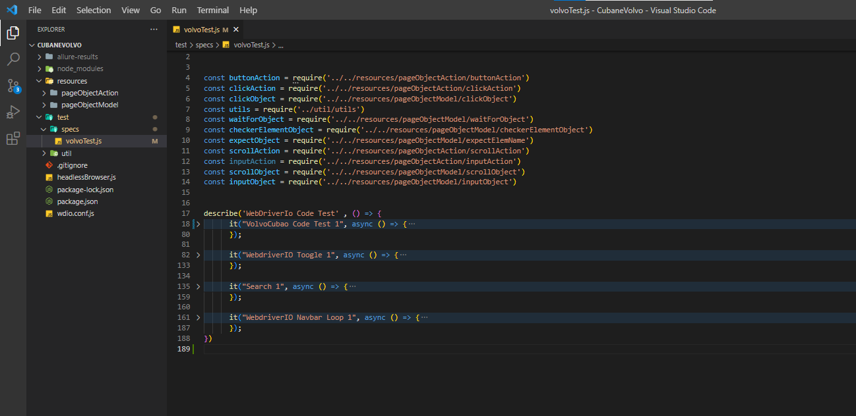

The first It is where we explore the getting started page in maximizeWindow or Full size page.  
I used **await** because it’s much simplier than using then. It waits for an asynchronous action before it proceed to the next line.

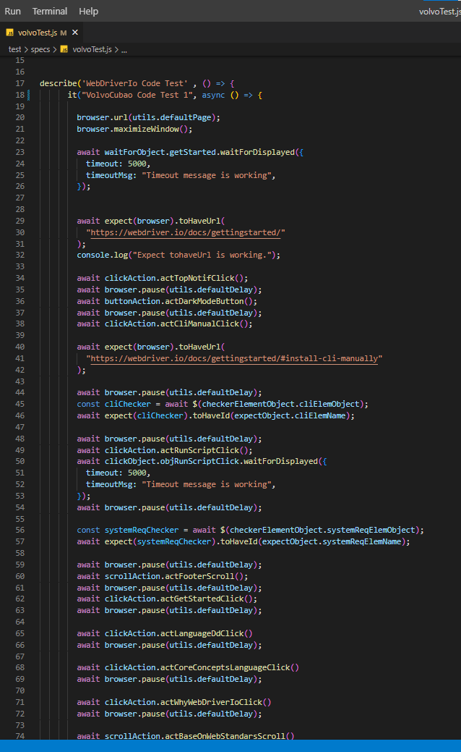I used **expect** as for literally expecting something as for security also so what it means is you’re expecting something on the given xpath and use a method of webdriverio it depends on what you need for example I used toHaveUrl(“ <https://webdriverio./docs/gettingstarted>”) it means the system or webdriverio is making sure that the automation is checking if you’re really on the given url.

In the 2nd It

I used a for loop to execute each one of the given element in the toogle bar in the burger in the top left. Execute some of the toogle bar and I used **expect** to check if the there is a given text by using **toHaveText**. By using toHaveText it means you’re checking if there is a text in the given xpath.

**Browse.pause() -** I’m using browser.pause to literally pause the automation for a few second/s to so a tester can see in which part his checking.

**Expect waitForExist -** I used this to check if the given text is existing in the given xpath.

**ScrollIntoView({behavior: “smooth”}) –** This is use for scrolling in the browser. The Behavior: “ smooth ” is optional because you can scroll in the given link immediately by using **instant**.

**Browser.setWindowSize()** – This is used to set the height and width of the browser.

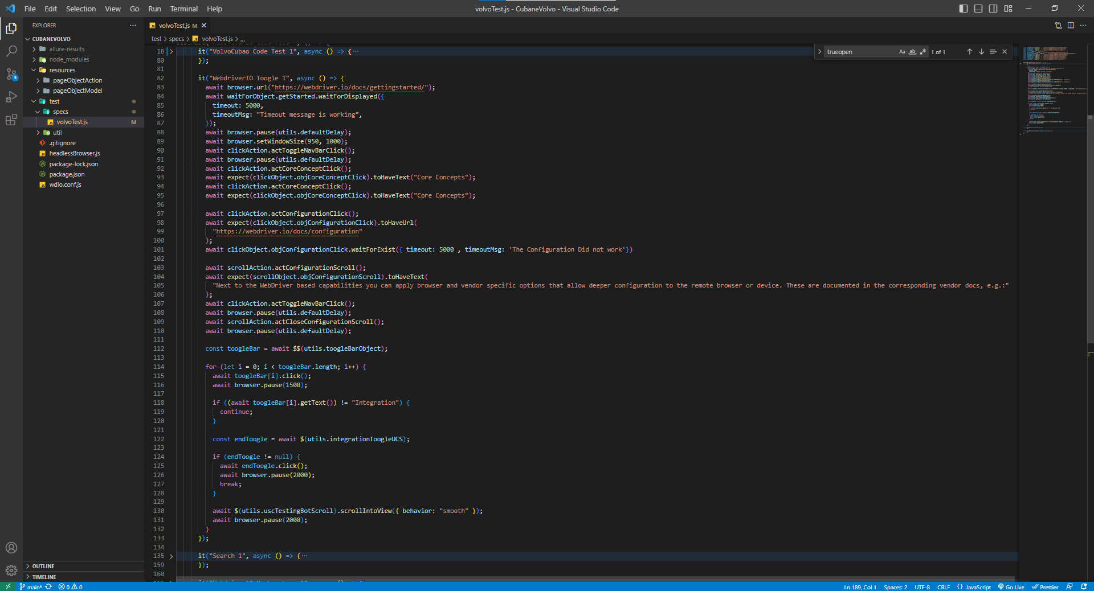

In the 3rd It

Inside of the 3rd it is about Search bar

**Browser.keys() –** What does it means is you can use it to access some of the keyboard function. For example I use the “ Enter “ to entered the scrollIntoView that I’ve searched.

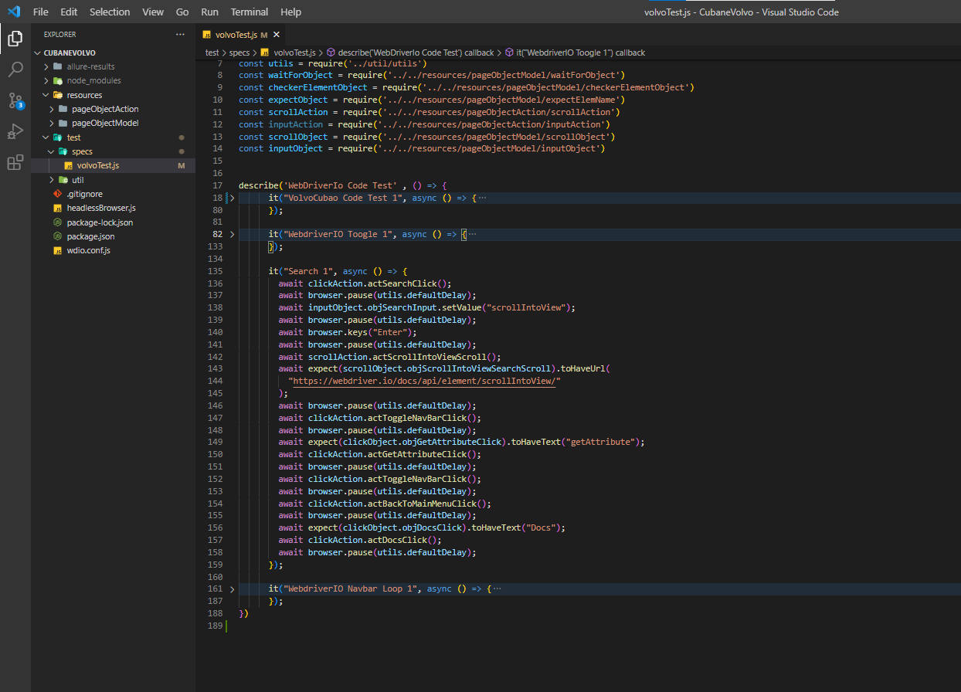

In the 4th it

I used for loop to execute each one of the element of the navBar in the getting started of the Webdriverio documentation.

**getUrl() –** I used this getUrl to check if I’m in the correct given URL specially this will be a big help if you’re switching windows.

**Browser.maximizeWindow() –** This is use if you want to test in a maximize window of a browser.

